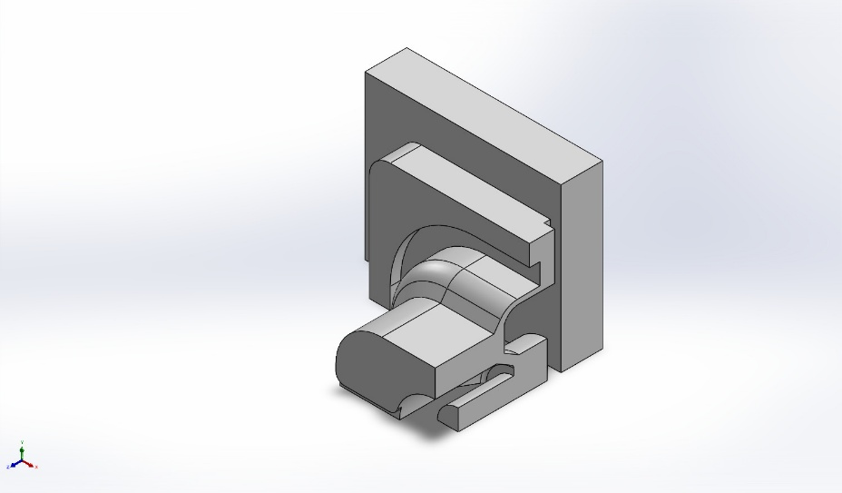 | Simulation of Press the rubber button repeatedly  Date: April 26, 2026  Designer: Solidworks  Study name: Nonlinear 1  Analysis type: Nonlinear - Static  Table of Contents  Description 1  Assumptions 2  Model Information 2  Study Properties 3  Units 3  Material Properties 4  Loads and Fixtures 5  Connector Definitions 6  Interaction Information 6  Mesh information 7  Sensor Details 8  Resultant Forces 9  Beams 9  Study Results 10  Conclusion 12

Description
No Data

Assumptions

Model Information

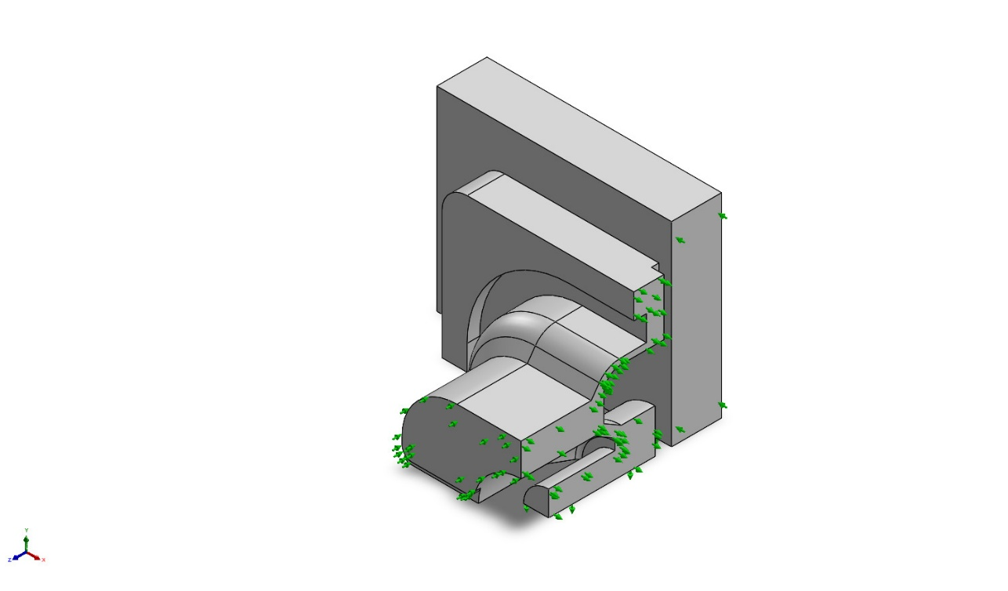
Model name: Press the rubber button repeatedly
Current Configuration: Default
Solid Bodies
Document Name and Reference | Treated As | Volumetric Properties | Document Path/Date Modified
Imported1  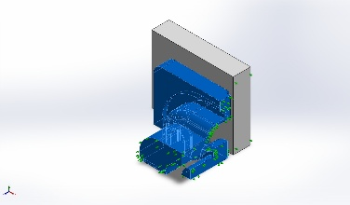 | Solid Body | Mass:8.3356e-05 kg  Volume:8.68292e-08 m^3  Density:960 kg/m^3  Weight:0.000816889 N | C:\Users\26869\Desktop\game\Solidwork\resource\model\第56课\Press the rubber button repeatedly.SLDPRT
Imported2  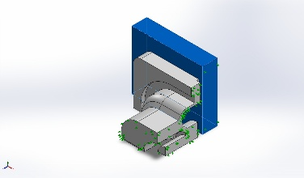 | Solid Body | Mass:0.00014847 kg  Volume:1.45559e-07 m^3  Density:1,020 kg/m^3  Weight:0.00145501 N | C:\Users\26869\Desktop\game\Solidwork\resource\model\第56课\Press the rubber button repeatedly.SLDPRT

Study Properties
Study name | Nonlinear 1
Analysis type | Nonlinear - Static
Mesh type | Solid Mesh
Start time | 0 Seconds
End time | 6 Seconds
Time increment | Auto stepping
Compute free body forces | Off
Contact penalty stiffness scale factor | 1
Large displacement formulation: | On
Update load direction with deflection: | Off
Large strain formulation: | Off
Save data for restarting the analysis | Off
Thermal Effect: | On
Thermal option | Include temperature loads
Zero strain temperature | 298 Kelvin
Solver type | Large Problem Direct Sparse
Incompatible bonding options | Simplified
Control technique: | Force
Iterative technique: | NR(Newton-Raphson)
Integration Method | Newmark
Result folder | SOLIDWORKS document (C:\Users\26869\Desktop\game\Solidwork\resource\model\第56课)

Units
Unit system: | SI (MKS)
Length/Displacement | mm
Temperature | Kelvin
Angular velocity | Rad/sec
Pressure/Stress | N/m^2

Material Properties
Model Reference | Properties | Components
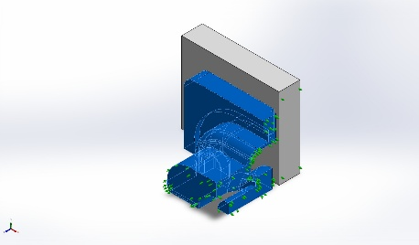 | Name: body you  Model type: HyperElastic - Mooney Rivlin  Default failure criterion: Unknown  Poisson's ratio: 0.45  Mass density: 960 kg/m^3 | SolidBody 1(Imported1)(橡胶按键)
Curve Data:
Simple Tension

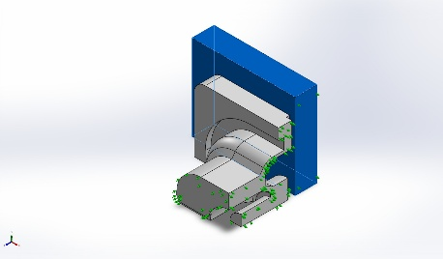 | Name: ABS  Model type: Linear Elastic Isotropic  Default failure criterion: Unknown  Tensile strength: 3e+07 N/m^2  Elastic modulus: 2e+09 N/m^2  Poisson's ratio: 0.394  Mass density: 1,020 kg/m^3  Shear modulus: 3.189e+08 N/m^2 | SolidBody 2(Imported2)(橡胶按键)
Curve Data:N/A

Loads and Fixtures
Fixture name | Fixture Image | Fixture Details | Function Curve
Symmetry-1 | 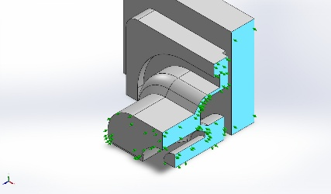 | Entities: 4 face(s)  Type: Symmetry
Resultant Forces
Components | X | Y | Z | Resultant
Reaction force(N) | -0.278233 | 0.291003 | 0.0655814 | 0.407918
Reaction Moment(N.m) | 0 | 0 | 0 | 0

Fixed-1 | 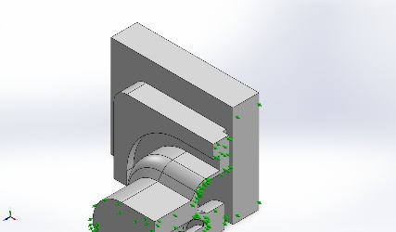 | Entities: 1 face(s)  Type: Fixed Geometry
Resultant Forces
Components | X | Y | Z | Resultant
Reaction force(N) | 0.266454 | -0.274634 | 0.843945 | 0.926642
Reaction Moment(N.m) | 0 | 0 | 0 | 0

On Flat Faces-1 | 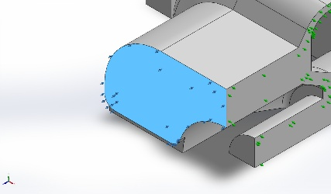 | Entities: 1 face(s)  Type: On Flat Faces  Translation: ---, ---, -1.2  Units: mm  Time variation: on | Time curve
Resultant Forces
Components | X | Y | Z | Resultant
Reaction force(N) | 0 | 0 | -0.843946 | 0.843946
Reaction Moment(N.m) | 0 | 0 | 0 | 0

Connector Definitions
No Data

Interaction Information

Interaction | Interaction Image | Interaction Properties
Local Interaction-1 | 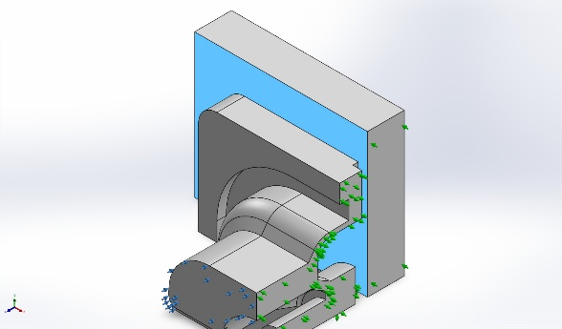 | Type: Contact interaction pair  Entities: 2 face(s)  Advanced: Surface to surface
Contact/Friction force
Components | X | Y | Z | Resultant
Contact Force(N) | -1.4733E-05 | 1.5158E-05 | -0.5328 | 0.5328

Local Interaction-2 | 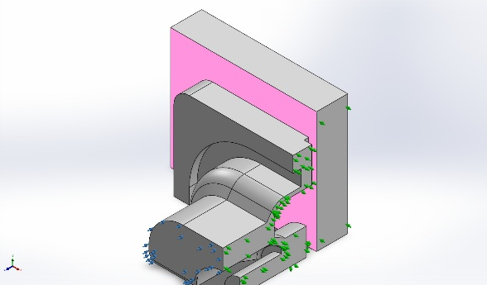 | Type: Contact interaction pair  Entities: 2 face(s)  Advanced: Surface to surface
Contact/Friction force
Components | X | Y | Z | Resultant
Contact Force(N) | 4.2402E-07 | -7.5849E-08 | -0.31115 | 0.31115

Mesh information
Mesh type | Solid Mesh
Mesher Used: | Blended curvature-based mesh
Jacobian points for High quality mesh | 16 Points
Maximum element size | 0.861166 mm
Minimum element size | 0.0803635 mm
Mesh Quality | High

Mesh information - Details
Total Nodes | 14660
Total Elements | 8647
Maximum Aspect Ratio | 13.34
% of elements with Aspect Ratio < 3 | 92.9
Percentage of elements with Aspect Ratio > 10 | 0.081
Percentage of distorted elements | 0
Time to complete mesh(hh;mm;ss): | 00:00:03
Computer name: | REMY

Mesh Quality Plots
Name | Type | Min | Max
Quality1 | Mesh | - | -
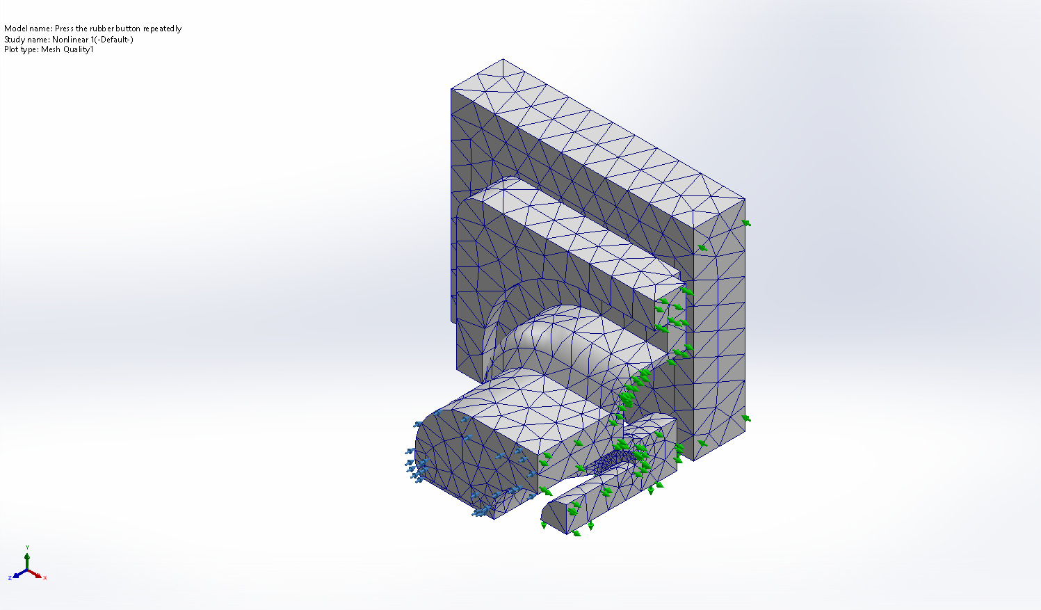
Press the rubber button repeatedly-Nonlinear 1-Quality-Quality1

Sensor Details
No Data

Resultant Forces

Reaction forces
Selection set | Units | Sum X | Sum Y | Sum Z | Resultant
Entire Model | N | 7.94389e-08 | -1.00117e-08 | 6.78119e-08 | 1.04925e-07

Reaction Moments
Selection set | Units | Sum X | Sum Y | Sum Z | Resultant
Entire Model | N.m | 0 | 0 | 0 | 0

Free body forces
Selection set | Units | Sum X | Sum Y | Sum Z | Resultant
Entire Model | N | 0 | 0 | 0 | 0

Free body moments
Selection set | Units | Sum X | Sum Y | Sum Z | Resultant
Entire Model | N.m | 0 | 0 | 0 | 0

Beams
No Data

Study Results

Name | Type | Min | Max
Stress1 | VON: von Mises Stress at Step No: 23(6 Seconds) | 5.518e+01N/m^2  Node: 14656 | 1.401e+06N/m^2  Node: 1962
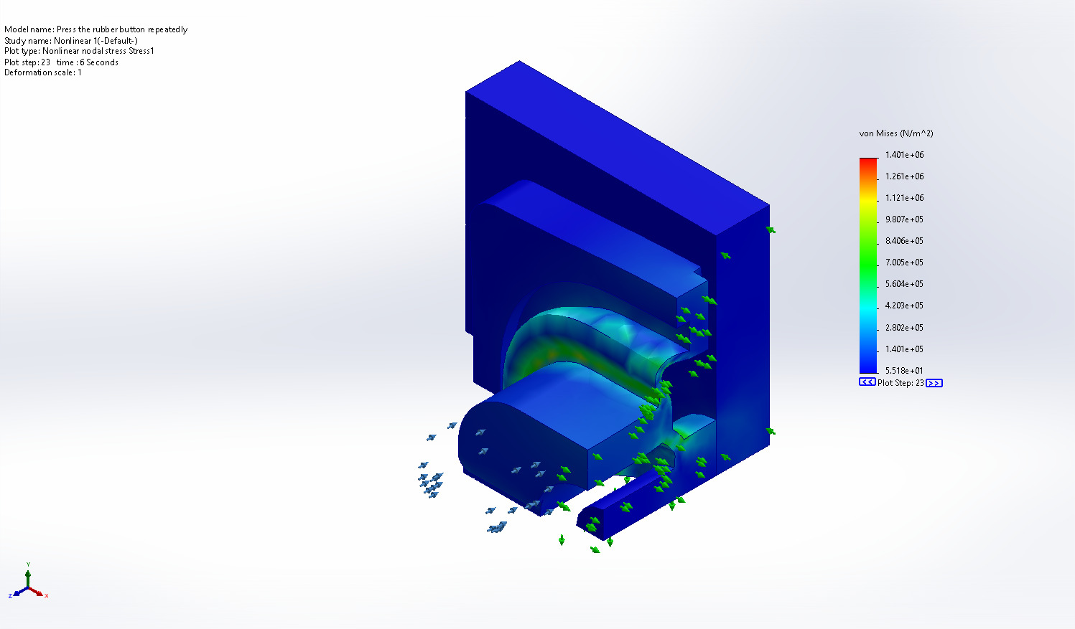
Press the rubber button repeatedly-Nonlinear 1-Stress-Stress1

Name | Type | Min | Max
Displacement1 | URES: Resultant Displacement at Step No: 4(0.9 Seconds) | 0.000e+00mm  Node: 11474 | 1.082e+00mm  Node: 610
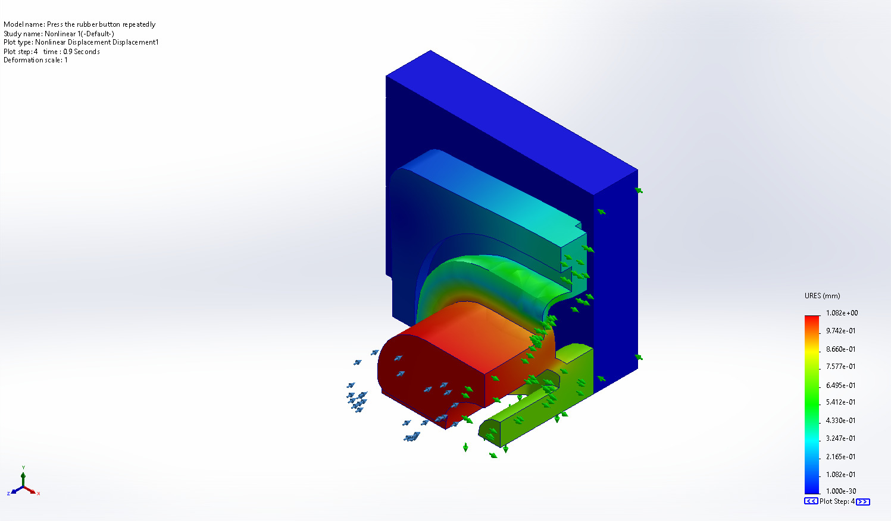
Press the rubber button repeatedly-Nonlinear 1-Displacement-Displacement1

Name | Type | Min | Max
Strain1 | ESTRN: Equivalent Strain at Step No: 14(3.3 Seconds) | 3.427e-11  Element: 7058 | 3.856e-04  Element: 6647
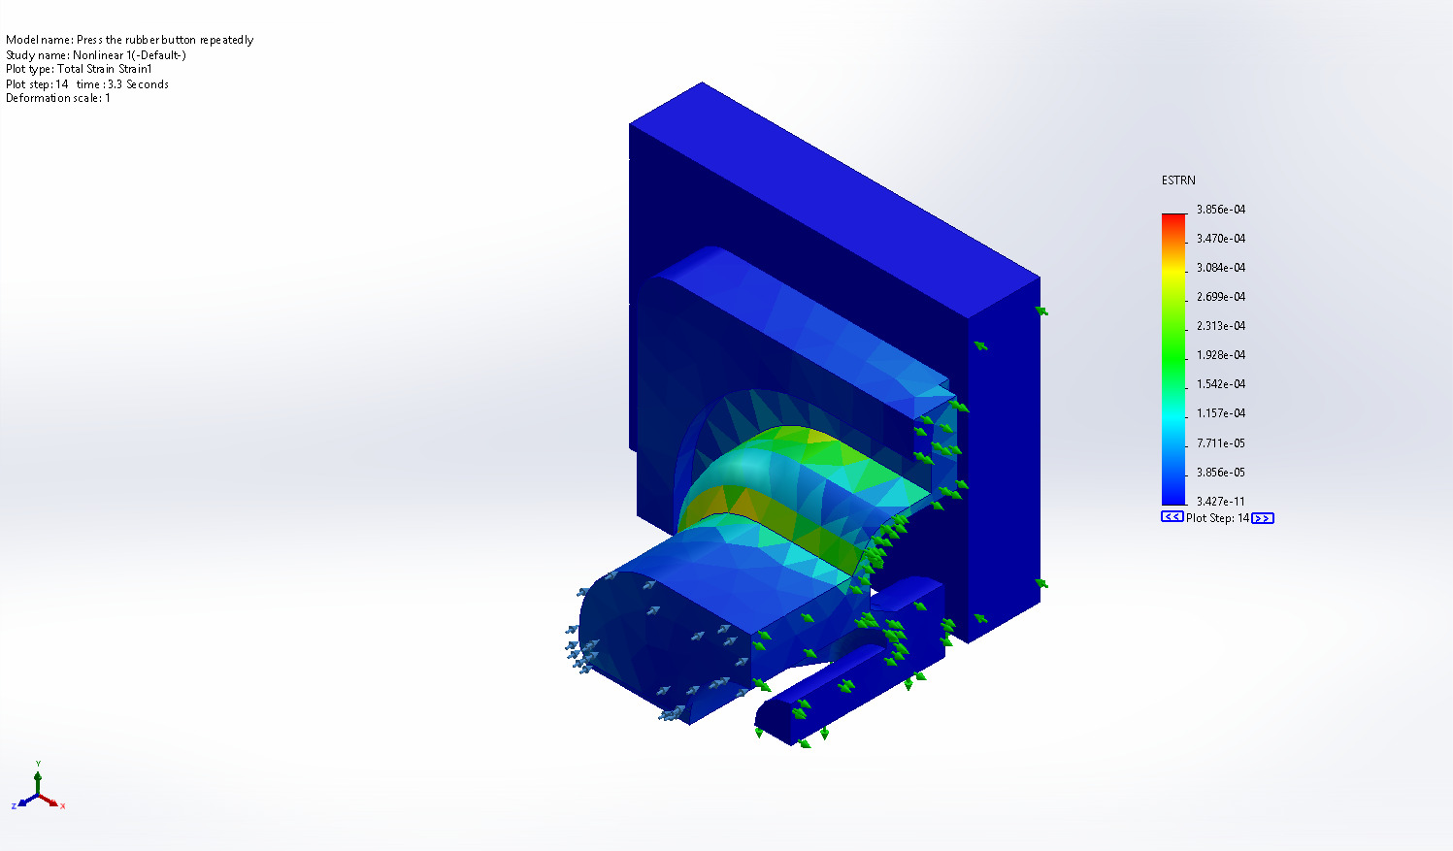
Press the rubber button repeatedly-Nonlinear 1-Strain-Strain1

Conclusion

